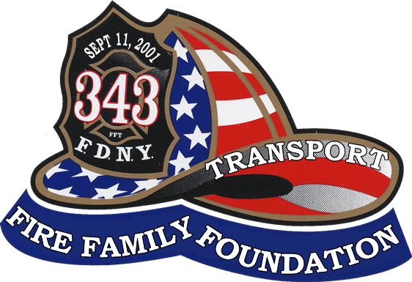

November 2014

Dear Friend,

We invite you to support the FDNY Fire Family Transport Foundation through the purchase of a Journal Ad for our 3rd Dinner Dance Event. This event will take place on Friday, February 27, 2015, at Russo’s on the Bay in Howard Beach. We had over 900 attendees at our last dinner and are working towards making this year’s event even more successful.

Your ad in the Souvenir Journal will demonstrate your business’s commitment to New York City’s Firefighters and help us fulfill our mission of assisting firefighters in their times of greatest need with transportation to and from necessary medical care and support in times of bereavement. The Foundation is all-volunteer, entirely non-profit, and all net proceeds go directly to funding these causes.

For more than 20 years, the FDNY Fire Family Transportation Foundation has been faithfully serving our active and retired members through the generosity of partners like you. We hope that we can count on your support to raise the funds necessary for our continued operations - the purchase of additional vehicles to meet the increasing demand as more FDNY personnel are affected with 9/11 related illnesses, as well as the maintenance of our current fleet of vans and antique rigs. Together, we can be there for the members of the FDNY, who so bravely serve our City, when the need arises.

Please see the attached sheet for Journal Advertising opportunities. If you would like additional information, please feel free to contact one of the event organizers listed below or you can send an email to RCannon@firefamilytransport.org.

On behalf of the FDNY Fire Family Transport Foundation, thank you for your consideration and support. As always, your generosity is greatly appreciated.

Sincerely Yours,

Richie Cannon Gene Stolowski

917-577-1173 845-825-4114

The FDNY Fire Family Transport Foundation is a non-profit, all volunteer organization, supported solely through donations. We are a 501(c)(3) foundation. Your donations are tax-deductible.
www.firefamilytransport.org

THE FDNY FIRE FAMILY TRANSPORT FOUNDATION
DINNER DANCE

FEBRUARY 27, 2015

JOURNAL ADVERTISING OPPORTUNITIES

Inside Cover Page…....$1,000
Full Gold Page…………$300
Full White Page………..$200
Half Page………………$100
Quarter Page…………….$50
Business Card……….…..$30

Please circle which size ad you are ordering.
Advertiser information must be submitted by:
January 27, 2015

Advertiser Name: _________________________________________________________

Address:_______________________________________ Amount Enclosed:__________

City:___________________ State:___________ Zip:____________

Telephone:_______________________________________________________________

Contact Person:___________________________________________________________

Email (email address that ad will be sent from):_________________________________

Web Site Address of Business:_______________________________________________

Please email electronic ad file as a PDF to RCannon@firefamilytransport.org
Hard copy ready art work material can be mailed with checks payable to:
Fire Family Transport Foundation
P.O. BOX 340949
Brooklyn, NY 11234

For more information, please contact:
Richie Cannon Gene Stolowski
917-577-1173 845-825-4114
RCannon@firefamilytransport.org gene@firefamilytransport.org
The FDNY Fire Family Transport Foundation is a non-profit, all volunteer organization, supported solely through donations. We are a 501(c)(3) foundation. Your donations are tax-deductible.
www.firefamilytransport.org

